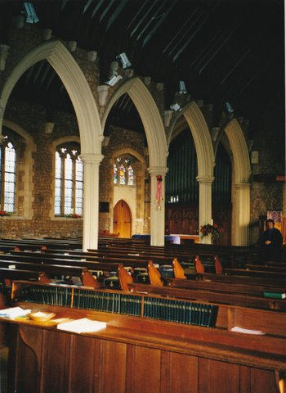
The Friends of
St Peter’s

How you can help:
Please tick the appropriate box and fill in your name and address in BLOCK CAPITALS and sign
Life Membership £200
Individual Membership £10/pa
Family Membership £25
Corporate Membership £30
Donation enclosed
I wish to pay by bankers order
I am a UK taxpayer
Name: ……………………………………………………….
Signature:…….……………………………………………
Address:……………………………………......................
………………………………………………………………....

The Friends of
St Peter’s Bedford
36 De Parys Avenue
Bedford
MK40 2TP
Postcode:…………………………………………………..

Cheques should be made payable to “The Friends of St Peter’s, Bedford.” and sent with the completed form to:
The Friends of St Peter’s
36 De Parys Avenue, Bedford.
MK40 2TP.

The Friends of
St Peter de Merton
with
St Cuthbert
Bedford

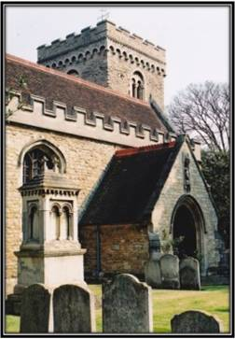

A place of worship for over 1,000 years
St Peter de Merton
Todays building contains many interesting features:

- Much evidence of Saxon work including two 6 ft high monoliths, long-and-short stonework, a round-headed arch of limestone rubble and a runic stone embedded in a triangular doorway.

- Magnificent Norman doorway arch in the south porch.

- Octagonal 14th century font.

- Hanoverian Coat of Arms above the south door.

- Several beautiful stained glass windows – some containing fragments of medieval glass.

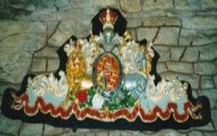
This ancient church is thought to contain the oldest architectural remains in Bedford. Some stonework from the Anglo-Saxon building has survived storms, fire, alteration and expansion.

St Peter’s was originally a small church outside the town walls and was first known as ‘St Peter in the fields’. The name ‘de Merton’ probably came from Merton Priory in Surrey and this title was used from the 12th century.

In 1010 the church was burned down by ransacking Vikings and its history is not clear until its restoration in the 13th century.

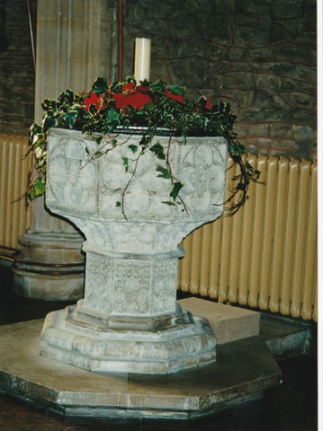

- Have you worshipped in St Peter’s?
- Were you baptized or married here?
- Have you attended concerts, recitals or lectures in the church?
- Are you interested in preserving an important part of Bedford’s history?
If you can answer ‘yes’ to any of these questions then please consider joining
The Friends of St Peter’s

Friends will receive an annual newsletter, are invited to an open day every year and to regular events in the church.

